

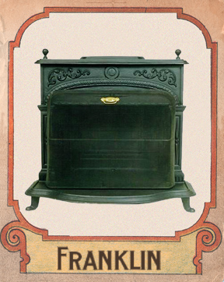 Benjamin Franklin has done it again with another one of his great inventions, the Franklin Stove. This stove generates more heat than most other stoves; it has two differentiating features like that there was a hollow baffle and a flue that was like an inverted siphon.

The baffle is very wide but with a thin iron box, which is open to the rooms’ air. It got more heat from the fire and the fumes so it was warmer than most stoves.

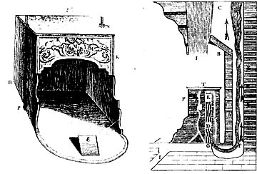 The Franklin stove was around a 30 foot tall box. The front was open except a panel on the upper part of the box. Also the back of the box was place a couple inches away from the chimney. On the bottom they were many holes that lead

to the chimney so the more heat could be made and so that the smoke could escape. This is another one of his great inventions